# WiSE Indicator for NinjaTrader 8 User Documentation

# Version 2.01.0 2020-03-04

## Introduction

Introduction

The WiSE (Wizdough Second Entry) Indicator is a powerful tool designed for traders and price action enthusiasts using the NinjaTrader 8 platform. It provides alerts on two-legged pullback status, enabling users to identify more than 16 different price action signals such as second entries, higher lows, lower highs, and failed second entries (traps). With its flexible setup and multiple filters, the WiSE Indicator can be used for teaching beginners, notifying traders about upcoming opportunities, and even implementing automated strategies or algorithmic trading.

Based on Mack's adaptation of Al Brooks' original technique, although this indicator is designed to work with any bar type and timeframes, it is particularly popular and optimized for the ES 2000 ticks chart and a 21-period Exponential Moving Average (EMA).

The WiSE 2.0 Indicator is designed to help traders identify potential entry points based on price action patterns. As illustrated in the chart, the indicator identifies various signals, such as new highs (0), first entry signals (1), second entry signals (2), lower highs (H), and higher lows (L).

When a new high is followed by a higher high, the indicator labels it as zero (0). The first entry signal bar is marked as one (1), and the second entry signal bar is marked as two (2). These numbers are displayed at signal bars, as they provide crucial information for placing stop orders.

Additionally, the indicator identifies lower highs (H) and higher lows (L) between the zero (0) and second entry (2) signals. These signals can also be used as entry points in the right context.

The WiSE 2.0 Indicator uses different colors to represent the status of each signal:

* **Grey symbols**: Indicate hidden signals that were filtered out based on your settings.
* **Yellow symbols**: Represent predicted signals. For example, a yellow (2) means the second entry is expected as soon as a bar breaks the previous bar. When this occurs, the (2) symbol will change to green or red, depending on whether it's a long or short entry signal.

By understanding these signals and their color coding, traders can better analyze price action and make more informed trading decisions.

## Key Features

- Highly customizable to meet individual trading requirements

- Displays minimal or comprehensive information based on user preferences

- Flexible alerts for various trading scenarios

- Offers a variety of filters, with more to be added in future versions

- Lightweight and easy to learn for traders of all levels

- Fast performance on charts and during backtesting

- Supports 3rd party strategies

## Installation and Requirements

To use the WiSE Indicator, you must have NinjaTrader 8 installed on your computer.

To install or update, from the Control Center window select the menu Tools > Import> NinjaScript Add-On... to open the "Import" dialog window ([NinjaTrader Addon installation guide](https://ninjatrader.com/support/helpGuides/nt8/index.html?using_3rd_party_add-ons.htm#InstallingAdd-Ons)). Restart NT.

To uninstall go to Tools > Remove NinjaScript Assembly.

## Configuration and Setup

After installing the WiSE Indicator, you can configure its settings to match your preferences. Please also check out preinstalled templates for the indicator.

* **Full control**: Shows maximum signals with all history. This might be too crowded for daily use but may be good for better understanding how signals form;
* **Minimalist**: demonstrates the concept of how can be displayed just the most important information;
* **Radio**: Listen to what’s happening on the chart;
* **Reduced nose; PT16**:balanced amount of signals, adapted for NQ with profit = 16 ticks;
* **Swings**: shows all swings.

The various settings and their explanations are listed below:

### Parameters

These settings control the core functionalities of the WiSE 2.0 Indicator.

* **Display Symbols**: Toggles the display of letters on the chart.
* **Dual Break Entry Index**: Specifies the starting entry index, starting from which all subsequent entries will require two breaks.  
  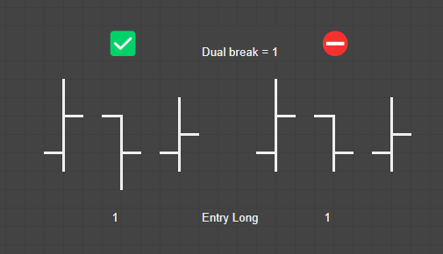
* **Reset on Double Top/Bottom**: Treat Double Top and Double Bottom patterns as New High and New Low.
* **Use engulfing bars**: Counts engulfing bars as second entries.
* **Profit Target (ticks)**: Sets the number of ticks used to calculate failed entries. Second entries are considered failed if they achieve less than the Profit Target. The indicator tests Second Entries (SE) for success or failure. Successful SEs are marked as (2). If an SE doesn't reach the threshold and then breaks the prior bar in the opposite direction, it will be marked as Challenged (c). If it then breaks the implied stop behind the SE signal bar, it will be marked as failed (x).

### Filters

These settings allow you to apply various filters to the WiSE 2.0 Indicator. Filters generally hide some signals and symbols by turning them into the "Hidden Color". This color should not be bright, so it doesn't attract your attention to unqualified symbols. While testing it's recommended not to use Transparent color because it may cause confusion.

* **Hide Long Signals**: Hides long entry signals on the chart.
* **Hide Short Signals**: Hides short entry signals on the chart.
* **Max count HL/LH**: Sets the maximum number of Lower High (LH) or Higher Low (HL) signals per zero entry.
* **Max count Entries**: Sets the maximum number of entries per zero entry.
* **Hide Inside Bar**: Hides second entry signals with inside bars.
* **Hide 0/1 without 2**: Hides zero entry and first entry signals without a corresponding second entry.  
  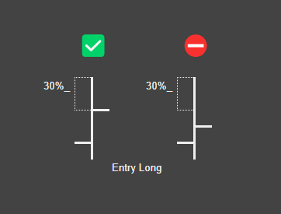
* **Apply filters to HL/LH when applicable**: Treats HL/LH same as entries to filter (See picture)
* **Apply filters to Failed/Challenged Entries**: If the originally filtered entry failed/challenged should it also be hidden or visible (See picture)
* **Max High-Close (long) & Close-Low (short) %, 0:off**: Enables hiding bars that do not meet the specified percentage difference between High-Close (for long) or Close-Low (for short).  
    
  For example, if this parameter is 30 the following filtering will be true for the long entry:
* **Hide Entries by Max Risk (ticks), 0:off**: Enables hiding bars that do not meet the specified maximum risk in ticks.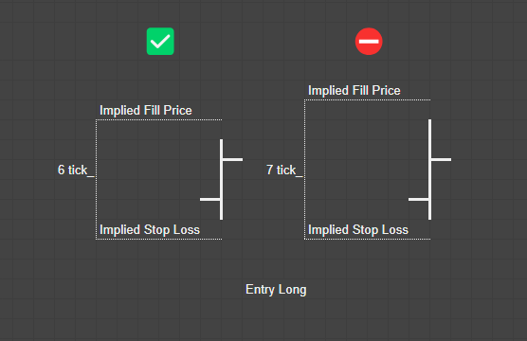  
  Here is an example for the parameter set to 6.
* **Hide Entries by color**: Hide if signal bar red for long / green for short
* **Max towards trade wick size (ticks), -1:off**: Enable this to hide bars that have longer then specified wick pointed to the trade direction. (See picture)
* **Hide Entries by Moving Average**: Hide if Close is indented from MA  
  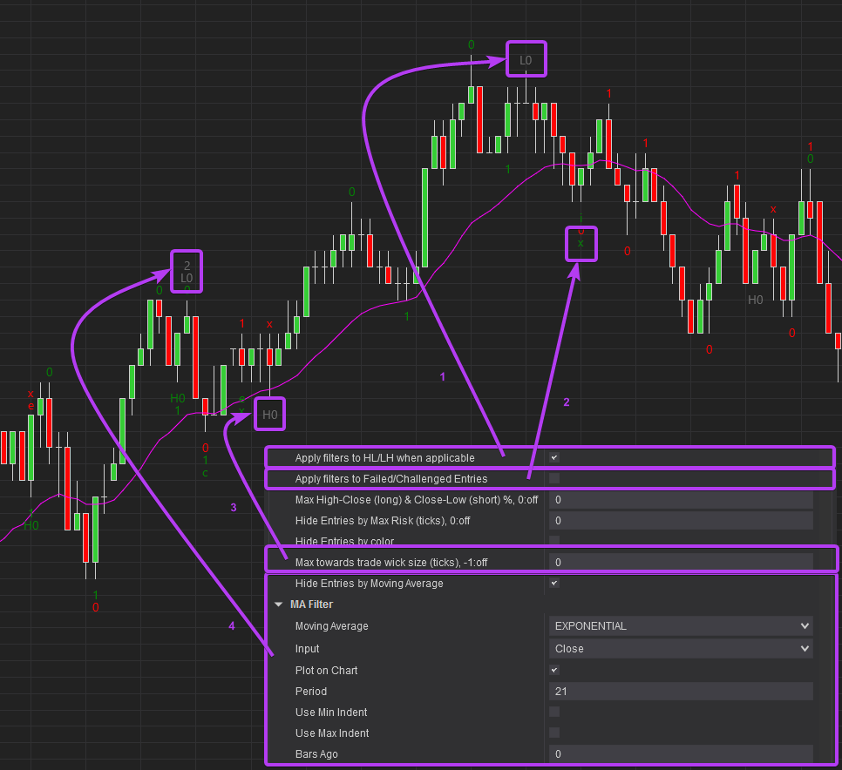

### Symbols

These settings allow you to customize the symbols used for various signal types. You can choose a single letter, group of letters, or even emojis to represent each signal type. Just a few options:

* Minimalistic: ^ ` ~ - + _ | . ;
* Abbreviations: 2EL, SEL, F2EL;
* Emoji (Hotkey - “Win + .”): ✌👍 ✔ 🤦‍♂️▼ ▲ ↓ ↑ .

Symbols:

* **New High**: Symbol for New High signals.
* **New Low**: Symbol for New Low signals.
* **First Entry Long**: Symbol for First Entry Long signals.
* **First Entry Short**: Symbol for First Entry Short signals.
* **Second Entry Long**: Symbol for Second Entry Long signals.
* **Second Entry Short**: Symbol for Second Entry Short signals.
* **Lower High**: Symbol for Lower High signals.
* **Higher Low**: Symbol for Higher Low signals.
* **Failed Second Entry Long**: Symbol for Failed Second Entry Long signals.
* **Failed Second Entry Short**: Symbol for Failed Second Entry Short signals.
* **Challenged Second Entry Long**: Symbol for Challenged Second Entry Long signals.
* **Challenged Second Entry Short**: Symbol for Challenged Second Entry Short signals.
* **Entry Followed by Inside Bar Long**: Symbol for Entry Followed by Inside Bar Long signals.
* **Entry Followed by Inside Bar Short**: Symbol for Entry Followed by Inside Bar Short signals.
* **Engulfing Bar Long**: Symbol for Engulfing Bar Long signals.
* **Engulfing Bar Short**: Symbol for Engulfing Bar Short signals.

### Appearance

These settings control the visual aspects of the WiSE 2.0 Indicator.

* **Symbol padding**: Adjusts the spacing between the symbols displayed on the chart.
* **Long Entry Color**: This setting allows you to customize the color of the symbols representing long entry signals on the chart.
* **Short Entry Color**: This setting enables you to customize the color of the symbols representing short entry signals on the chart.
* **Hidden Color**: This setting allows you to choose a color for the symbols representing hidden signals. Hidden signals are signals that were filtered out based on your filter settings. By selecting a specific color, you can identify which signals were hidden and assess the effectiveness of your filters.
* **Unconfirmed Color**: This setting enables you to customize the color of the symbols representing unconfirmed or predicted signals. Unconfirmed signals are signals that have not yet met all the criteria to be considered valid entry signals.
* **Show all symbol state history**: Displays the entire history of symbol states on the chart.

### Signals

These settings allow you to customize the signals to plot and alert.

* **Signal 1..12**: Select what symbols need to be plotted. Plotted signals can be used in Alerts and 3rd party strategies.

### Alerts

These settings allow you to enable or disable alerts for various signal types and assign specific sounds to each alert.

* **Enable Alert**: Toggles the alert for each signal type.
* **Sound**: Assigns a specific sound to each alert type.

By understanding and customizing these settings, you can tailor the WiSE 2.0 Indicator to suit your trading style and requirements. Experiment with different configurations to find the setup that works best for you.

## Usage

After configuring the WiSE Indicator settings to your preferences, apply the indicator to your chart. The WiSE Indicator will display signals and symbols on the chart based on the price action and configured settings. Use these signals to analyze the market and make informed trading decisions.

The WiSE 2.0 Indicator is designed to cater to traders with varying experience levels and preferences. Some common use cases include:

### New Traders

For new traders learning to count 2nd entries, the WiSE Indicator can display all signals before and after the second entry, helping users feel every move and understand how to count even without the indicator.

### Pro Traders

For more experienced traders, the Indicator can be set up to display only the signals they need. Pro traders can also use the flexible alerts system to get ready for their next trade.

As you gain experience with the WiSE Indicator, you may adjust the settings and filters to better suit your trading style and requirements.

### Using inside strategies

WiSE is designed for use in automated strategies (algo-trading). It generates special plots that can be used in your automated strategies.

## Conclusion

The WiSE Indicator is a versatile and powerful tool for NinjaTrader 8 users, offering valuable insights into price action through two-legged pullback status alerts. With its customizable settings and filters, the WiSE Indicator can be tailored to meet the needs of individual traders, making it a valuable addition to any trading toolkit.

## Change log

### 2.02.0 - 2023-08-28

- fix: predicted yellow symbols show up in SA

- fix: First entry tested and marked as failed when "Dual Break Entry Index" = 1

- feat: Apply filters to HL/LH when applicable

- feat: Option to apply filters to Failed/Challenged Entries

- feat: Max towards trade wick size. Enable this to hide bars that have longer than specified wick pointed to the trade direction.

- feat: Hide Entries by Moving Average. Hide if Close is indented from MA.

### 2.01.3 - 2023-08-13

- feat: Signal and alert for predicted entries (FEL_predict, FES_predict, SEL_predict, SES_predict)

- feat: Predict LH/HL

- feat: Better signal names

### 2.01.2 - 2023-06-29

- fix: Hide Risk works incorrectly

- fix: Hide 0/1 works incorrectly

### 2.01.1 - 2023-05-25

- fix: Max High-Close and Min Low-Close won't work

- fix: inside bar won't hide

- feat: Hide Entries by color

### 2.01.0 - 2023-03-04

Performance improved

Alerts redesigned

Plot signals redesigned

### 1.01.0 - 2020-03-04

Failed and Survived SE

Internal bars

Risk check filter

Bar quality check filter

Double top/double bottom reset

Symbol customization

Six plots for Alerts and automated strategies (FEL, FES, SEL, SES, HL, LH)

Improved prediction of next symbols

### 1.00.5 - 2020-02-02

Pro version available. Pro features: sell/buy signals for use in strategies

Optimized properties. Removed doubling configurations

Added symbols for long and short signals. Instead of just “2”, you can use ↑ and ↓ or any other symbol (press WIN+. to open emojis)